# Control Room overview and Running process from control room

Control Room is where process are schedule to run on a specific time or in a certain duration.

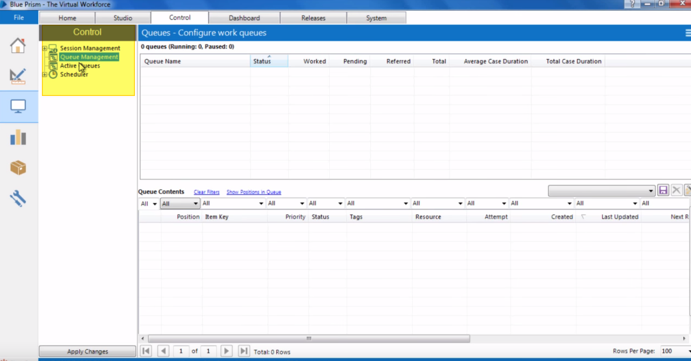

Control Room has following sections-

* Queue management
* Session Management
* Active Queue.
* Scheduler.

Session Management –

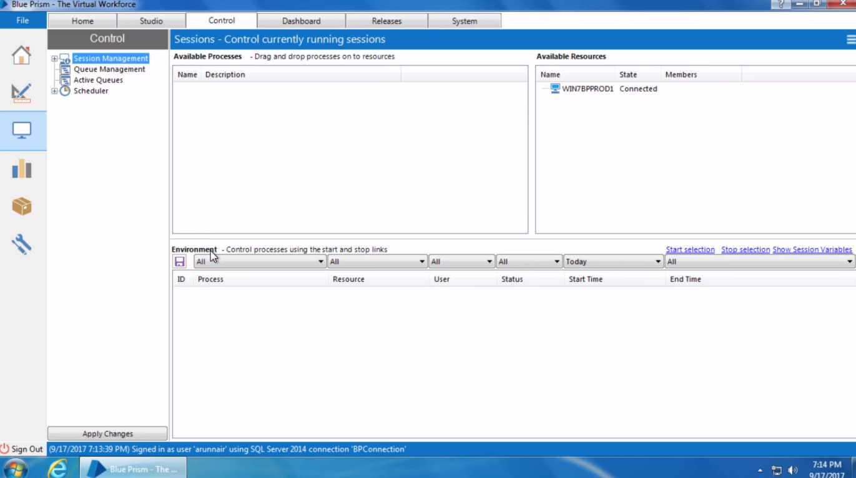

Session management section show three inherent sections.

1. **Available processes:** show all the available processes that is built in process studio and published to control room.
2. **Available resources:** shows list of computers with blue prism installed on them. If blueprism is installed on multiple systems and all are connected with blueprism server then the list of all those systems would be displayed here.
3. **Environment:** shows the list of processes that are assigned resources to run on.

How to run process from Control Room?

Go to Studio Tab. It shows list of processes under process section on left side. But none of the processes are shown in control room because those processes are not published.

Now in order to publish those processes. Open any process and click on process Information stage.

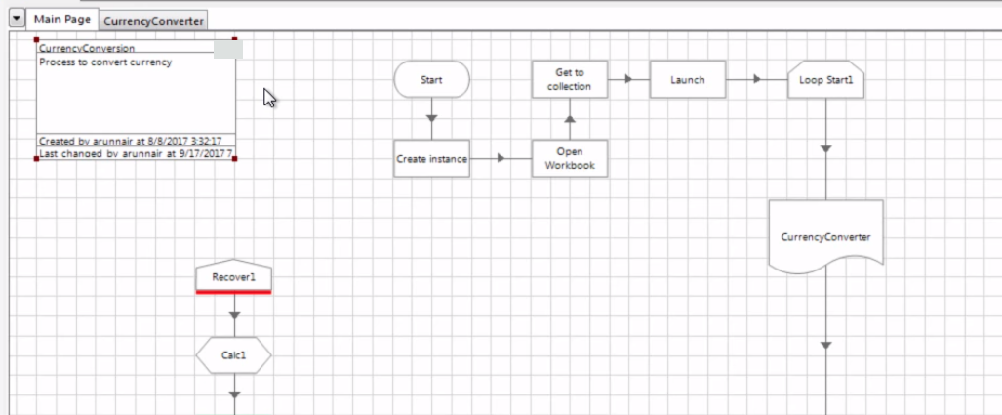

Double click on it and it shows up a new dialog.

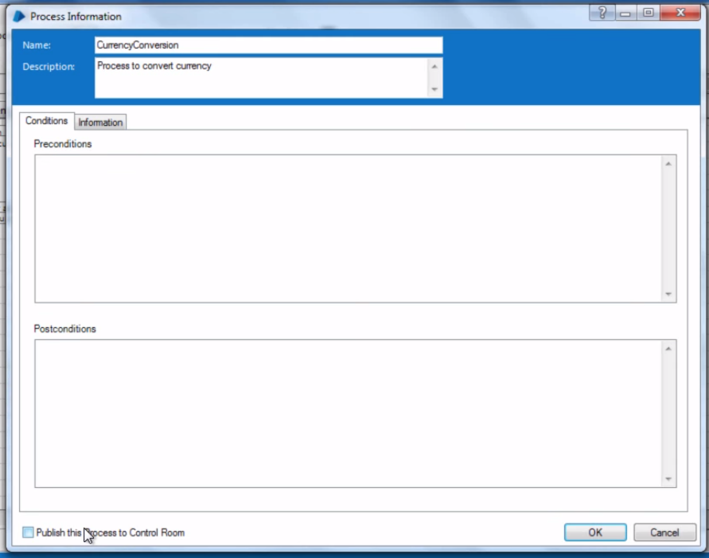

Process name and information can be changed from here if needed.

But to publish it click on the public this process to control room check box on bottom.

And click ok. The process is published now. And once its published there is a right tick mark get appeared on process information box.

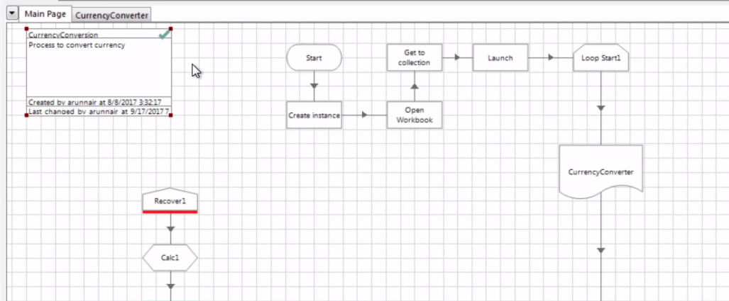

Now that published process can be accessed in control room

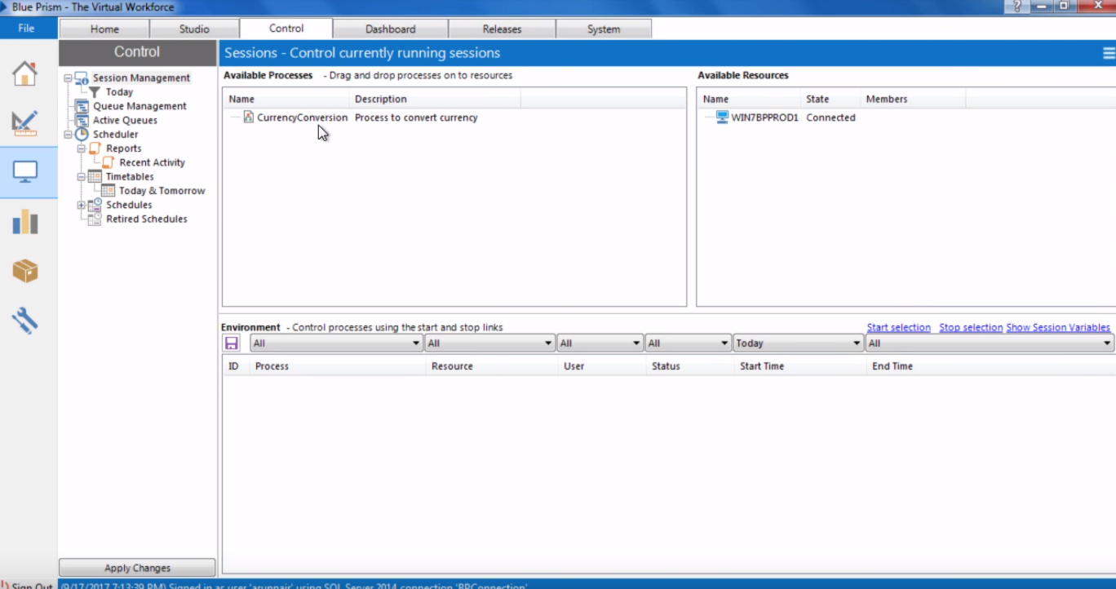

To run the process from control room just drag and drop the process from available process to a resource

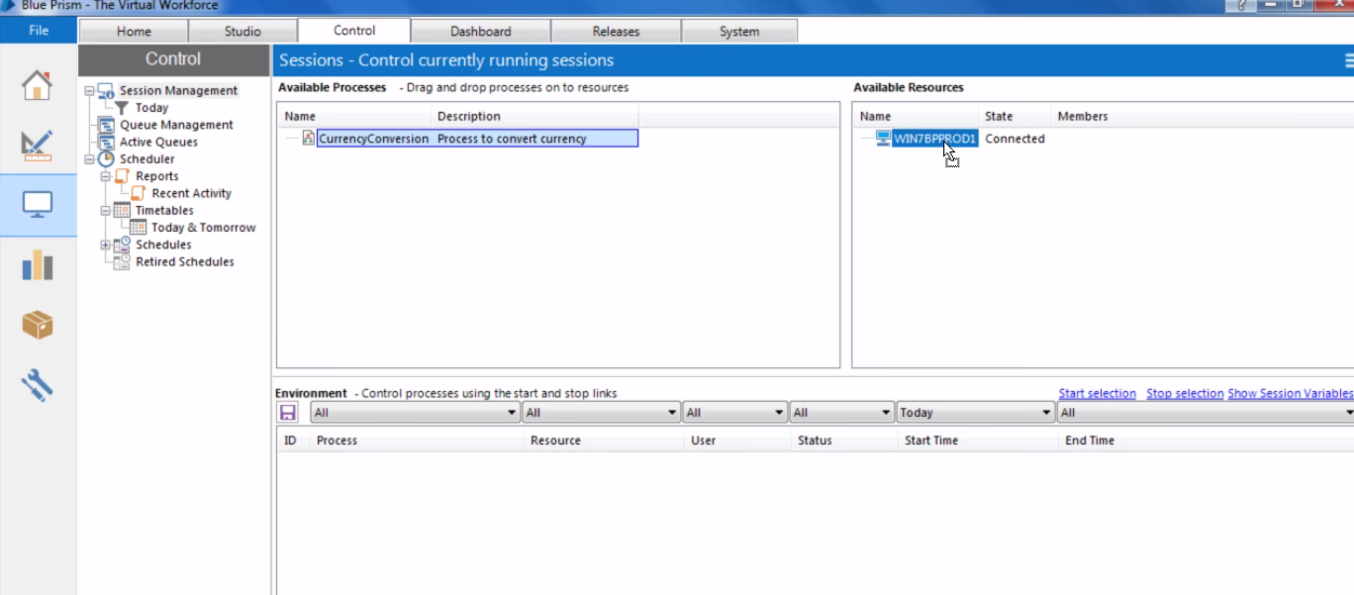

As soon as process is allocated any resource a new entry is created in environment-

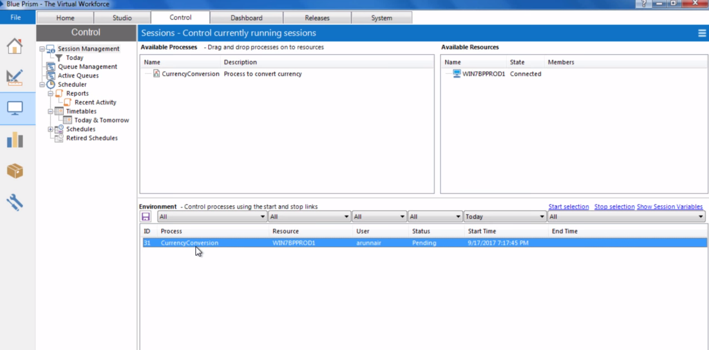

And this new entry is called session.

Remember whenever a fresh process is been allocated a resource the status will always be pending.

To run the process select the process and click start selection. And process will start. Once completed it’s status will be completed.

